SMALL OFFICE NETWORKS: A CASE STUDY ON NETWORK CONGESTION SOLUTIONS

A CASE STUDY REPORT

Submitted by

AKSHAT NEOLIA [RA2211031010080]

for the course
21CSC302J – COMPUTER NETWORKS
in partial fulfillment of the requirements for the degree of
BACHELOR OF TECHNOLOGY
in
COMPUTERS SCIENCE ENGINEERING
with specialization in INFORMATION TECHNOLOGY


DEPARTMENT OF NETWORKING AND COMMUNICATIONS SCHOOL OF COMPUTING
FACULTY OF ENGINEERING AND TECHNOLOGY SRM INSTITUTE OF SCIENCE AND TECHNOLOGY KATTANKULATHUR – 603203
NOVEMBER 2024



SRM INSTITUTE OF SCIENCE AND TECHNOLOGY KATTANKULATHUR – 603 203

BONAFIDE CERTIFICATE

Certified that Computer Network a Case Study Report titled “Small Office Networks: A Case Study on Network Congestion Solutions” is the bonafide work of Akshat Neolia [RA2211031010080] who carried out the case study under my supervision. Certified further, that to the best of my knowledge the work reported herein does not form any other work

SIGNATURE

Dr. C. FANCY
Assistant Professor
Department of Networking and Communications

Date: 12/11/2024
SIGNATURE

Dr. M LAKSHMI
Professor and Head Department of Networking and Communications

ABSTRACT

A small office network is a compact and structured computer network designed to support a limited number of users and devices within a business environment, typically encompassing fewer than 50 users. Its purpose is to facilitate seamless communication, resource sharing, and access to the internet, often within a single physical location. Core components include workstations, servers, routers, switches, and wireless access points, which work together to maintain network connectivity and performance. Security measures such as firewalls and secure Wi-Fi protocols are crucial for protecting sensitive data and ensuring safe access to network resources. These networks are typically optimized for cost-effectiveness, scalability, and ease of management, making them an ideal solution for small businesses.
A 2911 router connects the network to external resources, allowing for inter-VLAN communication and internet access. The use of access points in each VLAN facilitates wireless connectivity for devices within each department, ensuring flexibility in device mobility and access. Printers are assigned to specific VLANs, providing secure printing services to each respective department. This setup allows for effective resource sharing within each department while maintaining network segmentation for security. The network infrastructure, consisting of routers, switches, and VLANs, demonstrates a scalable design ideal for a small office, providing controlled access, network performance optimization, and efficient resource allocation across the departments.

Keywords: Small office network, VLAN segmentation, Admin/IT, Finance/HR, CS/Reception, IP addressing, access points, PCs, printers, 2911 router, 2960 switch, inter-VLAN communication, security, traffic management, scalability, resource allocation, network performance

TABLE OF CONTENTS
Abstract 2
- Introduction 4
- Network Design 6
- Routing Configuration 9
- Switching Configuration 12
- Inter-VLAN Routing 14
- DHCP Server Configuration 18
- Wireless Network Configuration 24
- Network Scalability Considerations 29
- Testing and Validation 33
- Results and Evaluation 37
- Conclusion 38
- References 39
- Appendices 40
TABLE OF FIGURES
FIGURE 1: TOPOLOGY OF FULL NETWORK 6
FIGURE 2: WIRELESS NETWORK SETUP WITH ACCESS POINTS 28
FIGURE 3: TRACEROUTE SUCCESSFUL 35
FIGURE 4: DHCP IP ALLOCATION 36
FIGURE 5: PERFORMANCE MEASURE THROUGH PING TIME 37

INTRODUCTION

Background
In today’s business landscape, even small offices rely heavily on efficient and secure computer networks to support daily operations, collaboration, and data management. A small office network is typically designed to connect a limited number of devices and users, providing essential resources such as internet access, file sharing, and printing. Unlike larger enterprise networks, a small office network prioritizes simplicity, cost-effectiveness, and ease of maintenance, often utilizing basic networking devices like routers, switches, and access points.
To ensure effective communication and security within different departments, small office networks commonly use VLANs (Virtual Local Area Networks). VLANs help segment the network into isolated sections, allowing departments to operate independently while sharing the same physical infrastructure. For instance, Admin, Finance, and Reception departments may each have their own VLAN, preventing unauthorized access between departments and managing data flow more efficiently. VLANs not only enhance security but also improve network performance by reducing unnecessary broadcast traffic within each segment.
The backbone of a small office network typically includes a central router and switch, which manage device connectivity and control data traffic. Access points enable wireless connectivity, allowing employees to access network resources from various locations within the office. This structured yet straightforward network setup ensures that all devices are interconnected, resources are accessible, and the network can scale as the office grows. By using VLANs and scalable components, a small office network is well-equipped to meet the demands of modern businesses in a flexible and secure manner.

Objectives
The primary objective of a small office network is to establish a reliable and efficient communication infrastructure that connects all employees and devices within the office. This includes enabling secure access to shared resources, such as files, printers, and internet services, while minimizing latency and disruptions. By segmenting the network with VLANs, the objective is also to enhance security, ensuring that sensitive information within departments, like Finance or HR, is protected and

accessible only to authorized personnel. Additionally, this segmentation helps in managing network traffic more effectively, reducing congestion, and optimizing bandwidth usage.
Another key objective is to ensure scalability and adaptability for future growth. The network design should allow the addition of more users, devices, or departments with minimal restructuring, enabling the small office to expand without significant disruptions to its IT infrastructure. Furthermore, providing both wired and wireless connectivity ensures flexibility, allowing employees to connect from various locations within the office. Ultimately, the objectives are focused on achieving a balance between performance, security, and flexibility, creating a robust network foundation that supports productivity and efficient workflows.

NETWORK DESIGN

Topology
The topology of a small office network typically follows a star or hybrid star-bus configuration, where all devices connect to a central switch or series of interconnected switches. This central switch acts as a hub, connecting each department's devices—such as computers, printers, and access points—while also linking them to the main router, which provides internet access and inter-VLAN routing. Each department is assigned a unique VLAN, creating isolated network segments that enhance security and manage traffic. Wireless access points within each VLAN provide flexible connectivity options for mobile devices. This setup ensures that the network is both structured and scalable, allowing new devices or departments to be added with ease while maintaining efficient communication and resource sharing across the office.

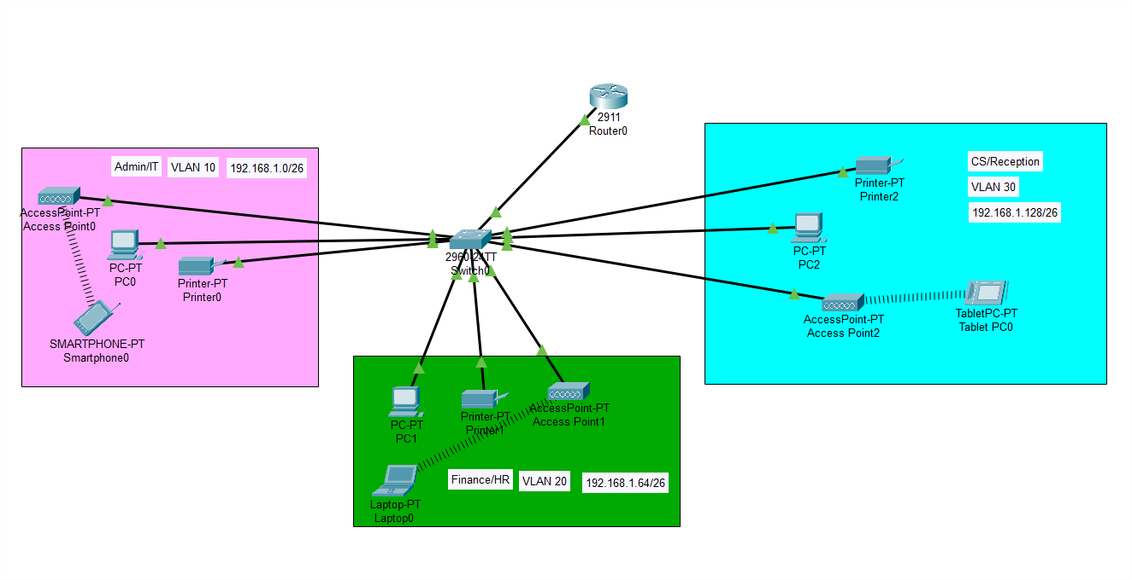
Figure 1: Topology of full network

Components

    - Router (2911 Router) – Provides internet access and manages inter-VLAN routing, allowing communication between different VLANs securely.

    - Switch (2960 Switch) – Acts as the central hub for connecting all devices, including PCs, printers, and access points, within each VLAN.

    - VLANs (Virtual Local Area Networks) – Segments the network into isolated sections (Admin/IT, Finance/HR, CS/Reception) to improve security and traffic management.

    - Access Points – Enable wireless connectivity for mobile devices within each VLAN, ensuring flexible access to the network.

    - PCs (Workstations) – Used by employees in each department for accessing shared resources, internet, and department-specific applications.

    - Printers – Assigned to each VLAN, allowing for secure and department-specific printing resources.

    - IP Addressing Scheme – Assigns unique IP ranges to each VLAN, organizing devices and managing network traffic within the specified segments.

These devices collectively form a structured and well-organized network architecture, integrating redundancy, efficient routing, and secure communication to meet the specific requirements of the office centre’s operations.

IP Addressing Scheme

Base Network: 192.168.1.0/24

Department | Network Address | Subnet mask | Host Address Range | Broadcast Address
Admin/ IT | 192.168.1.0 | 255.255.255.192/26 | 192.168.1.1 to  192.168.1.62 | 192.168.1.63
Finance/ HR | 192.168.1.64 | 255.255.255.192/26 | 192.168.1.65 to  192.168.1.126 | 192.168.1.127
CS/ Reception | 192.168.1.128 | 255.255.255.192/26 | 192.168.1.129 to  192.168.1.190 | 192.168.1.191

ROUTING CONFIGURATION

Router Configuration
The basic router configuration for a small office network involves setting up inter-VLAN routing, configuring IP addresses, and implementing security settings. First, the router is assigned an IP address on each VLAN's subnet to enable communication between VLANs. Sub-interfaces are configured on the router for each VLAN, with each sub-interface tagged with a VLAN ID and assigned the appropriate IP address for that subnet. Routing is then enabled to allow traffic between these VLANs as needed. Static or dynamic routing protocols, such as RIP or OSPF, may be used if the network requires routing beyond the local VLANs. Additionally, access control lists (ACLs) are applied to filter traffic and ensure security by controlling which devices or VLANs can access specific resources. Finally, NAT (Network Address Translation) is set up to allow internal devices to access external networks, such as the internet, while protecting internal IP addresses. This configuration establishes a secure, segmented, and interconnected network that meets the requirements of a small office.

Static routing is implemented within the router to enable communication between the VLANs, as the network design does not require dynamic routing protocols like RIP or OSPF. The router simply routes traffic between VLANs by recognizing the IP subnets associated with each VLAN’s sub-interface. This allows devices in different departments to communicate without requiring additional routing protocols, simplifying the network structure.

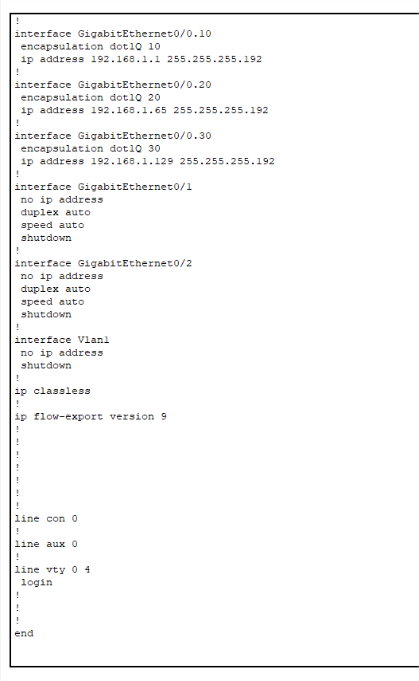

Static and Dynamic Routing
Static and dynamic routing are two methods for directing data traffic within a network. Static routing involves manually configuring routes on the router by specifying the exact paths that data packets should follow to reach specific destinations. It is simple and secure, as the routes do not change unless manually updated, but it requires more administrative effort, especially in larger networks where routes might change frequently. Dynamic routing, on the other hand, uses routing protocols like RIP, OSPF, or EIGRP, which automatically discover and update routes based on real-time network changes. This approach is more scalable and adaptable, as routers can communicate and adjust routes dynamically if there are link failures or topology changes, ensuring efficient and reliable data flow. While static routing is ideal for smaller or stable networks, dynamic routing is more suitable for larger, more complex networks that need adaptability and redundancy.
Static routing is implemented within the router to enable communication between the VLANs, as the network design does not require dynamic routing protocols like RIP or OSPF. The router simply routes traffic between VLANs by recognizing the IP subnets associated with each VLAN’s sub-interface. This allows devices in different departments to communicate without requiring additional routing protocols, simplifying the network structure.

SWITCHING CONFIGURATION

Switch Configuration

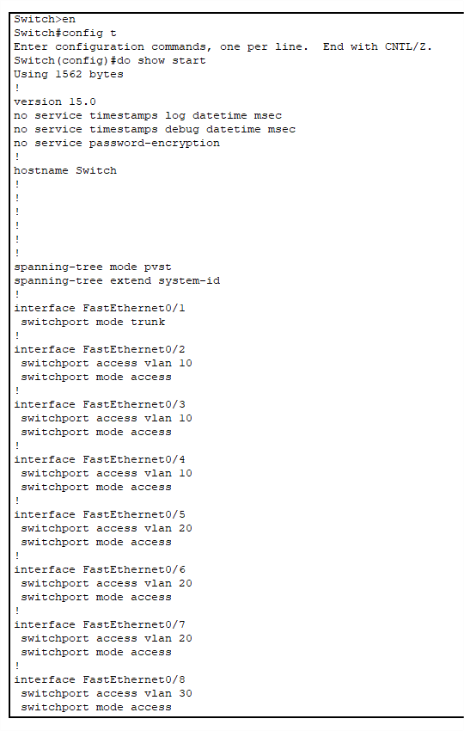

  - VLAN's
The VLAN setup in a small office network is essential for segmenting traffic between different departments, such as Admin/IT, Finance/HR, and CS/Reception. Each department is assigned its own

VLAN, creating isolated networks within the same physical infrastructure, which enhances security and performance. For example, devices in the Finance/HR VLAN are kept separate from the Admin/IT VLAN, preventing unauthorized access to sensitive financial data while still allowing controlled communication, when necessary, through inter-VLAN routing on the router. This segmentation reduces broadcast traffic within each VLAN, improving network efficiency and performance. Additionally, VLANs make it easy to manage resources and apply department-specific policies, ensuring that each team has reliable access to the network while maintaining a secure and organized infrastructure.



INTER-VLAN ROUTING

Layer 3 switching using SVIs
In a small office network, Layer 3 switching using Switch Virtual Interfaces (SVIs) enables efficient inter-VLAN routing. SVIs are virtual interfaces created on a Layer 3 switch, with each SVI assigned to a specific VLAN, allowing the switch to route traffic between VLANs without needing an external router. Each SVI is configured with an IP address in the VLAN’s subnet, serving as the default gateway for devices within that VLAN. This setup reduces network latency and enhances performance by keeping inter-VLAN traffic within the switch, providing faster data transfer compared to traditional router-based inter-VLAN routing. Layer 3 switching with SVIs is ideal for small office environments, as it consolidates routing and switching functions in one device, simplifying network management and supporting high- speed, secure communication between departments.
Layer 3 switching with SVIs is highly scalable, allowing small office networks to expand seamlessly. As the network grows, additional VLANs can be created and configured with their respective SVIs, with minimal impact on the network's performance. This scalability is particularly useful for small offices that may need to add new departments or expand existing ones without overhauling the network infrastructure.
Although advanced security measures like ACLs might not be configured, VLAN segmentation inherently provides a degree of security by isolating departments from each other. Layer 3 switches with SVIs control traffic between these VLANs, ensuring that only relevant traffic is routed between departments. This segmentation minimizes broadcast domains, preventing unnecessary traffic from affecting other parts of the network and reducing the risk of broadcast storms.

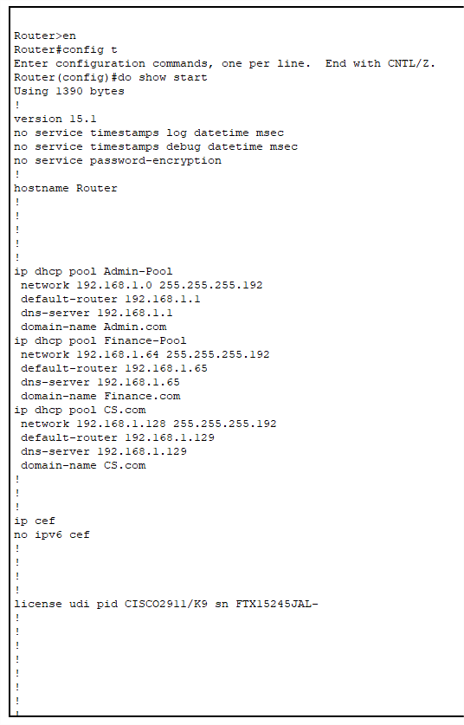

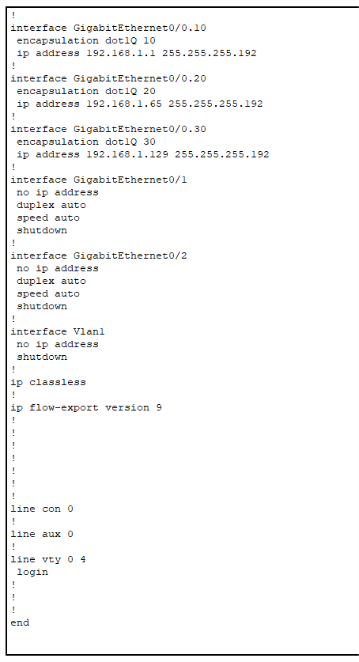

Subnetting
Subnetting further organizes a small office network by dividing the IP address space of each VLAN into manageable segments, aligning each subnet with a specific VLAN. By assigning each department its own subnet (e.g., 192.168.1.0/26 for Admin/IT, 192.168.1.64/26 for Finance/HR, and so on), subnetting provides an efficient way to allocate IP addresses while controlling network traffic and enhancing security. With subnetting, devices in different VLANs use different IP ranges, preventing unintended access between departments and making it easier to implement security policies. In conjunction with VLANs, subnetting allows the small office network to be scalable, organized, and ready for future expansion as new departments or devices are added to the network.

DHCP SERVER CONFIGURATION

In a small office network with multiple VLANs, a DHCP (Dynamic Host Configuration Protocol) server plays a crucial role in automatically assigning IP addresses to devices within each VLAN. Configuring the DHCP server to work with VLANs streamlines IP management by ensuring that each device in a VLAN receives an IP address from a specific subnet, reducing the need for manual IP configuration and minimizing potential IP conflicts. This section explains how the DHCP server is set up to automatically address devices in each VLAN, optimizing network operations and simplifying IP address management.

DHCP Pool Setup for Automatic Addressing
To provide automatic IP addressing, the DHCP server is configured with separate IP address pools for each VLAN. Each pool corresponds to a different subnet, matching the IP address range assigned to its respective VLAN. For example, in this network:

- VLAN 10 (Admin/IT) has an IP range of 192.168.1.1 - 192.168.1.62 (subnet mask /26).
- VLAN 20 (Finance/HR) has an IP range of 192.168.1.65 - 192.168.1.126 (subnet mask /26).
- VLAN 30 (Customer Service/Reception) has an IP range of 192.168.1.129 - 192.168.1.190 (subnet mask /26).

For each VLAN, a DHCP pool is created on the DHCP server to manage IP allocation. The configuration specifies:

- Pool Name: Unique identifiers for each VLAN's DHCP pool, such as DHCP-Pool-Admin, DHCP-Pool-Finance, and DHCP-Pool-CS.
- IP Range: Each pool includes the starting and ending IP addresses within the VLAN’s subnet to avoid assigning addresses outside the specified range.

- Default Gateway: Each pool designates the IP address of the router’s sub-interface (or SVI, if Layer 3 switching is used) as the default gateway, enabling devices in the VLAN to communicate with other VLANs.
- DNS Server: If applicable, DNS server addresses can be specified for name resolution.

This setup ensures that devices in each VLAN automatically receive an IP address, default gateway, and other network configurations without manual intervention. This is especially useful in dynamic environments where devices frequently connect to and disconnect from the network.

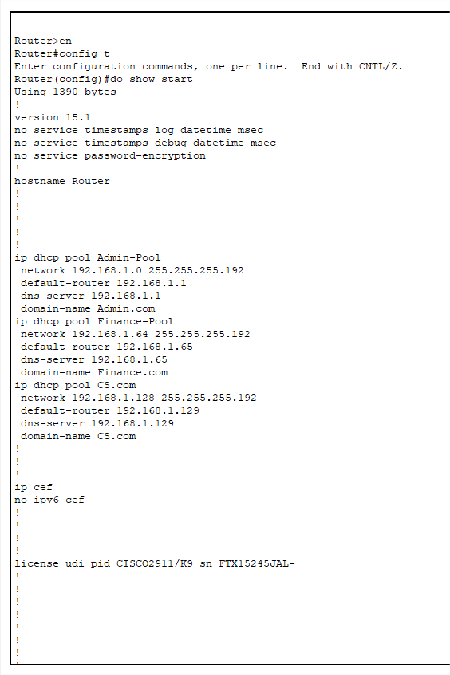

VLAN-Based DHCP Configuration

In VLAN-based DHCP configuration, the DHCP server recognizes the VLAN ID associated with each request, enabling it to assign IP addresses from the correct pool. There are two primary ways to achieve VLAN-based DHCP:

Router-on-a-Stick with DHCP Relay:
If a central DHCP server serves multiple VLANs, a DHCP relay agent (often configured on the router or Layer 3 switch) forwards DHCP requests to the server. The relay agent includes information about the originating VLAN, allowing the DHCP server to assign IP addresses from the appropriate pool. For example:

  - The router or switch listens for DHCP requests from devices in VLAN 10 and forwards these requests to the DHCP server with an identifier for VLAN 10.
  - The DHCP server recognizes the VLAN information and assigns an IP address from the DHCP-Pool-Admin pool for devices in VLAN 10.

DHCP Pools Mapped to VLAN Subnets:
In setups where the DHCP server is directly connected to the VLANs or integrated within the Layer 3 switch, DHCP pools can be mapped directly to the subnets of each VLAN. This configuration eliminates the need for a relay agent, as the DHCP server knows which pool to use based on the IP subnet of the requesting device. The server simply assigns IPs based on the VLAN from which the request originates, matching it to the correct IP address pool.

In this project, VLAN-based DHCP configuration is essential to ensure that each device within a VLAN receives an IP address from its corresponding subnet, maintaining network segmentation and organized IP address allocation. This configuration is particularly beneficial as it:

  - Simplifies Network Management: With automatic IP addressing, network administrators don’t need to assign IP addresses manually, saving time and reducing configuration errors.
  - Ensures IP Consistency: Each device consistently receives an IP address within its VLAN's subnet, ensuring smooth inter-VLAN routing and communication.

  - Supports Network Scalability: As the network grows and additional VLANs are added, new DHCP pools can be created and assigned to each VLAN without disrupting existing configurations.

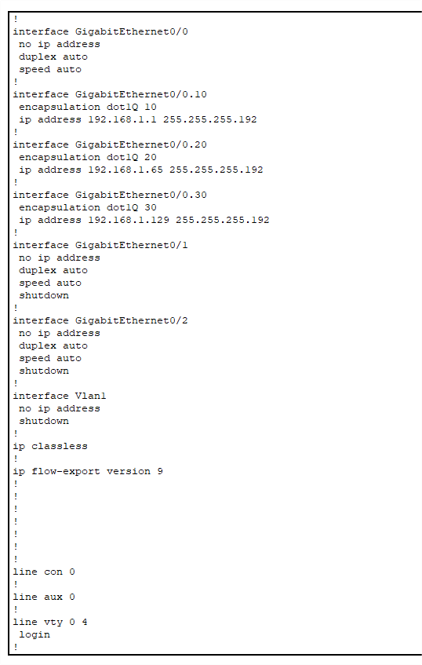

WIRELESS NETWORK CONFIGURATION

In this small office network, wireless access points are configured to provide connectivity tailored to each department. Using separate SSIDs for each VLAN ensures that wireless devices connect to the appropriate network segment, maintaining VLAN-based isolation while enabling inter-department communication as needed. Each SSID is secured with WPA2-PSK (Wi-Fi Protected Access 2 with Pre-Shared Key) authentication to provide robust encryption and restrict access to authorized users.

Wireless Access Setup for Each VLAN
To facilitate department-specific wireless access, each VLAN is assigned a dedicated SSID:
- Admin/IT (VLAN 10): SSID is "Admin-WIFI."
- Finance/HR (VLAN 20): SSID is "Finance-WIFI."
- Customer Service/Reception (VLAN 30): SSID is "CS-WIFI."
Each access point broadcasts these SSIDs, which are mapped to their respective VLANs. Devices connecting to a particular SSID automatically join the associated VLAN, ensuring they receive IP addresses from the correct DHCP pool and are segmented according to department.

VLAN Tagging on Access Points:
      - VLAN tagging is applied to each SSID on the access points, enabling proper segregation of traffic. Traffic from each SSID is tagged with its VLAN ID, allowing the switch to route data accordingly. This setup ensures that devices on each SSID are connected to their respective VLAN while enabling seamless inter-VLAN routing as needed.

Wireless Coverage and Roaming:
      - Access points are strategically placed within the office to ensure full coverage for each VLAN. Multiple access points can be configured to support the same SSIDs across different locations, allowing devices to roam without losing connectivity.

Security Measures for Wireless Networks
Security is crucial to protect the wireless network from unauthorized access and maintain data integrity.

WPA2-PSK authentication is implemented for each SSID, using strong, unique passwords to secure wireless access.

WPA2-PSK Authentication:
- WPA2-PSK provides robust encryption for each SSID, ensuring that only users with the correct pre-shared key can access the network. Each SSID has a unique password:
  - Admin-WIFI (for VLAN 10)
  - Finance-WIFI (for VLAN 20)
  - CS-WIFI (for VLAN 30)
- Using WPA2-PSK helps prevent unauthorized users from accessing the network and maintains secure data transmission across the wireless connection.

MAC Address Filtering (Optional):
- As an additional layer of security, MAC address filtering can be configured on each access point to restrict access to registered devices only. By allowing only known device MAC addresses, the network can prevent unauthorized devices from joining.

Network Isolation through VLAN Segmentation:
- VLAN segmentation ensures that devices connected to each SSID remain isolated within their VLAN. Inter-VLAN routing is configured to allow specific communication between departments, but the segmentation ensures that devices from one VLAN cannot access resources in another VLAN directly, reducing potential security risks.

SSID Broadcasting Control:
- SSID broadcasting can be selectively disabled for each department’s SSID to minimize visibility to unauthorized users. For example, the "Admin-WIFI" SSID could be hidden to reduce exposure, while other SSIDs remain visible for ease of access, depending on organizational requirements.

Regular Monitoring and Access Logging:
- Access points are configured to log connection attempts and network activity. Regular monitoring of these logs helps detect unusual activity, such as unauthorized access attempts, allowing network administrators to act promptly if necessary.
By implementing these configurations, this wireless setup provides secure, efficient, and department- specific wireless access. The use of WPA2-PSK authentication across the "Admin-WIFI," "Finance- WIFI," and "CS-WIFI" SSIDs enhances network security, ensuring that only authorized users can connect

to each VLAN. This approach enables a secure and streamlined wireless experience for the small office network.

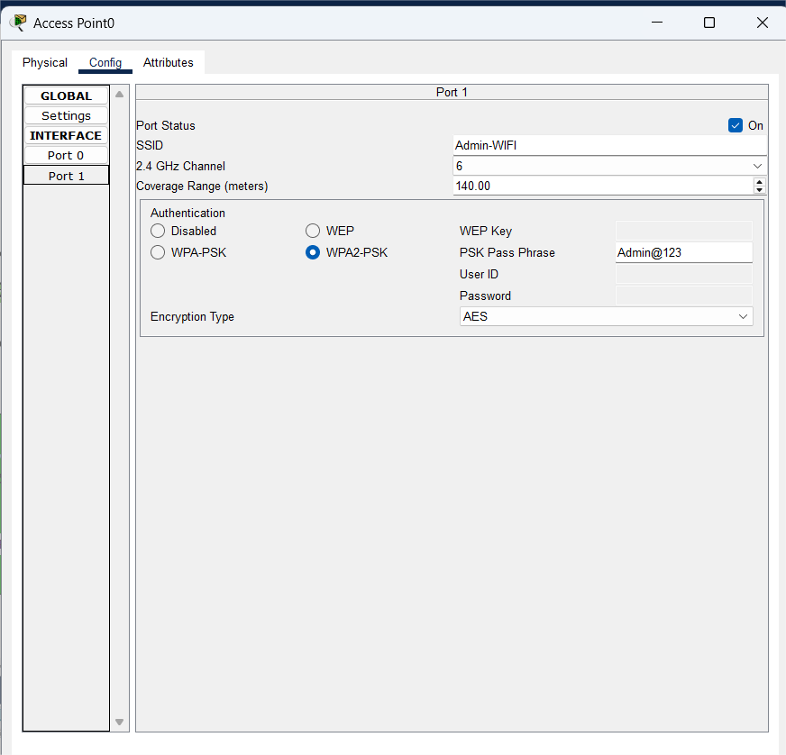

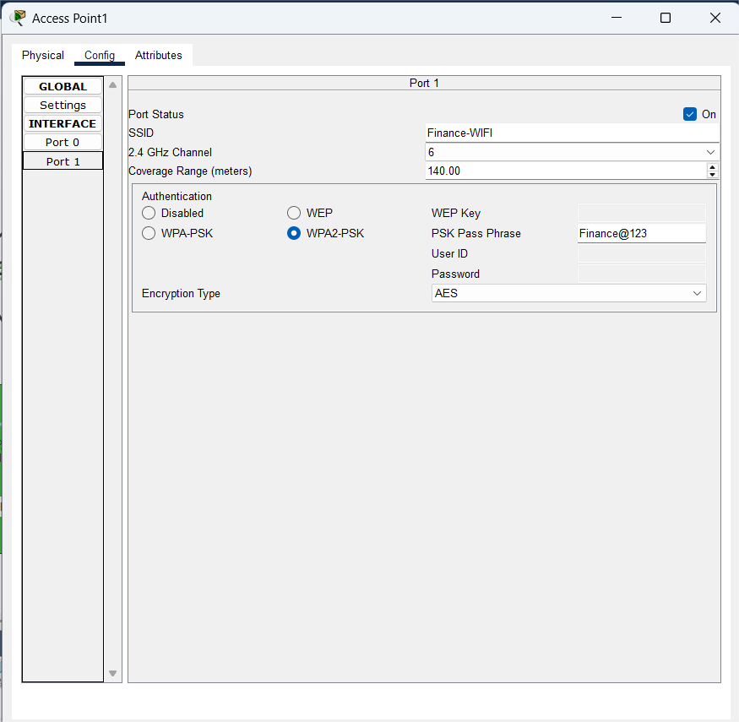

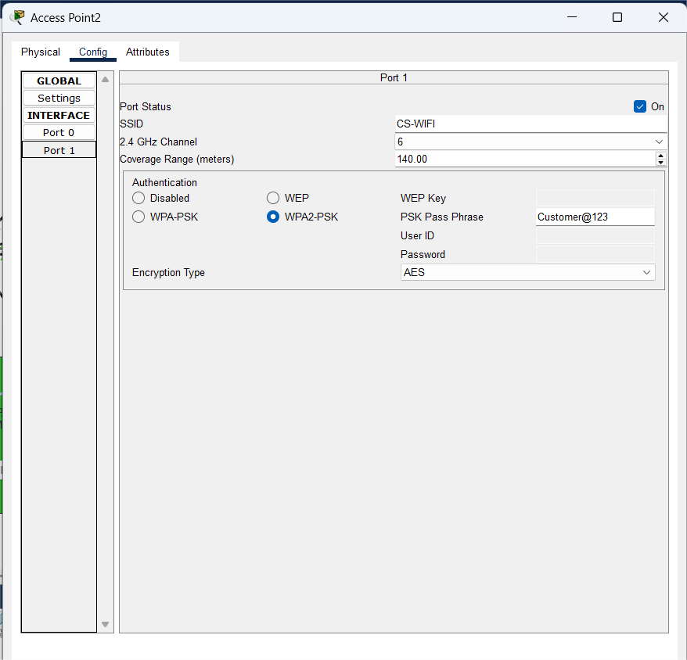

Figure 2: Wireless Network Setup with Access Points

NETWORK SCALABILITY CONSIDERATIONS

As the organization grows, the network must be able to accommodate new departments, devices, and additional network traffic without a complete redesign. By implementing scalability measures, the network can expand as needed while maintaining efficiency, security, and ease of management. This section explores the scalability considerations for VLAN expansion, IP addressing, and future needs related to network infrastructure.

Future Expansion of VLANs and IP Addressing
The network’s current VLAN setup and IP addressing scheme provide a strong foundation for expansion. Future expansion can involve adding new VLANs for additional departments or sub- dividing existing VLANs to better organize traffic and enhance security.

VLAN Expansion:
  - The current setup includes VLANs for the Admin/IT, Finance/HR, and Customer Service/Reception departments. As the organization expands, additional VLANs can be created for new departments, such as Marketing, Sales, or R&D.
  - Each new VLAN would be assigned a unique VLAN ID and IP subnet, enabling straightforward integration into the existing network. For example, VLAN 40 could be designated for a future Marketing department with its own IP range.
  - By maintaining a consistent VLAN naming and numbering scheme, the network can remain organized as new VLANs are added.

IP Addressing Scheme for Future Growth:
  - The IP addressing scheme is based on a subnetting plan that allows for efficient allocation of IP addresses within each VLAN. Each VLAN is currently assigned a /26 subnet, providing up to 62 usable IP addresses per VLAN. If necessary, the subnet mask could be adjusted to accommodate more devices in specific VLANs.
  - Alternatively, if the demand for IP addresses exceeds the current allocation, the network can be upgraded to a larger subnet, such as a /24, to accommodate up to 254 devices per VLAN. This change would provide greater flexibility as the number of devices grows.
  - Planning IP address allocation with future needs in mind reduces the need for

reconfiguration and ensures a seamless transition as new devices are introduced.

Addressing Space for Additional Offices or Remote Locations:
  - If the company plans to add remote offices or connect multiple branch networks, an IP addressing strategy can be adopted to differentiate between locations. This could involve reserving specific subnets for each location or using VPNs to connect branches securely.
  - The use of private IP address ranges across different locations allows for easy routing and expansion without IP conflicts, simplifying network management in a multi-location environment.

Scalability for Additional Departments and Devices
As the number of departments and devices grows, the network infrastructure should be capable of handling increased data flow and maintaining efficient communication between VLANs. Scalability considerations include preparing the network to accommodate new devices, adjusting access points for increased wireless traffic, and maintaining efficient inter-VLAN routing.

Scalability for Additional Departments:
  - With each new department, a new VLAN and corresponding SSID can be configured, allowing wireless and wired devices within that department to connect securely to the network.
  - The Layer 3 switch, which currently handles inter-VLAN routing, can support additional VLANs with minimal performance impact. However, if the number of VLANs becomes very large, additional routing or switching resources might be considered to ensure optimal performance.
  - The DHCP server can also be configured with additional IP address pools to accommodate new VLANs and ensure each device within the new departments receives an IP address within the appropriate subnet.

Wireless Network Scalability:
  - As more wireless devices are introduced, access points may need to be added or upgraded to handle increased traffic. The access points should support multiple SSIDs and VLAN tagging for new VLANs to maintain consistent wireless segmentation.
  - Configuring access points to handle seamless roaming between areas ensures that as employees move around, they maintain connectivity without disruptions. Additional access

points can be strategically placed to eliminate any coverage gaps.
  - Future-proofing access points with support for higher bandwidth and more concurrent connections (such as Wi-Fi 6 or later standards) can further improve performance and scalability as the network load increases.

Infrastructure Upgrades for Increased Traffic:
  - As the office grows, the Layer 3 switch may need to support higher traffic volumes due to increased inter-VLAN communication and data exchange. Ensuring that the switch has sufficient backplane capacity and port density is essential for maintaining network performance under heavy load.
  - If network traffic continues to grow, implementing a faster backbone connection (e.g., 10 Gbps links between core network devices) can prevent bottlenecks. These high-speed connections support smooth data flow between VLANs, critical for performance as the network expands.

Planning for Redundancy and Fault Tolerance:
  - As the network grows, the need for redundancy and fault tolerance increases. Adding redundant links and backup power sources (such as uninterruptible power supplies) can ensure high availability and reduce downtime in case of equipment failures.
  - Using a second DHCP server or implementing DHCP failover can provide continuous IP addressing services even if the primary DHCP server fails.

Documentation and Management Tools:
  - Proper documentation is critical for a scalable network. As VLANs and IP addresses are added, maintaining updated documentation helps prevent configuration errors and makes troubleshooting easier.
  - Network management tools, such as centralized monitoring software, can provide real-time insights into network performance, helping administrators manage network growth and identify areas that require upgrades.
By considering these scalability factors, the network can evolve to meet the future needs of the organization. The flexible design allows for smooth integration of additional VLANs, departments, and devices, ensuring the network remains efficient and secure as the organization expands. This forward-thinking approach minimizes future reconfiguration and downtime, providing a solid foundation for ongoing growth.

TESTING AND VALIDATION

Testing and validation are essential to confirm that the network configuration meets all operational requirements and performs as expected. This section outlines the tests conducted to verify VLAN connectivity, inter-VLAN communication, DHCP functionality, and overall network connectivity. These tests ensure that each component of the network functions correctly, providing seamless connectivity, efficient data routing, and reliable IP address assignment.

VLAN Connectivity Tests
VLAN connectivity testing confirms that devices within the same VLAN can communicate with each other. This step is crucial to ensure that VLAN segmentation is correctly configured and that all devices in a specific VLAN can connect to each other without interference from other VLANs.
- Ping Test: Devices within each VLAN (e.g., Admin/IT, Finance/HR, and Customer Service/Reception) are tested by pinging one another. Successful pings between devices in the same VLAN indicate proper VLAN segmentation and connectivity.
- Subnet Isolation: During VLAN testing, it’s also verified that devices from one VLAN cannot access devices in another VLAN unless explicitly allowed through inter-VLAN routing. This confirms that the VLANs are isolated as intended, which maintains network security and segmentation.
- Broadcast Control: Broadcast tests are also performed to verify that broadcast traffic is confined within each VLAN, ensuring that unnecessary traffic does not affect other VLANs.

Inter-VLAN Communication Tests
Inter-VLAN communication testing ensures that devices in different VLANs can communicate as intended through inter-VLAN routing. This test verifies that the Layer 3 switch or router is correctly routing traffic between VLANs, allowing controlled data exchange between departments.
- Inter-VLAN Ping Test: Devices from one VLAN (e.g., Admin/IT) are pinged from devices in another VLAN (e.g., Finance/HR). Successful ping responses confirm that the router or Layer 3 switch is effectively routing traffic between VLANs.
- Access Control Validation: If specific access controls or routing restrictions are applied, they are verified during testing to ensure that only authorized communication occurs between VLANs. For instance, some VLANs may have limited access to certain resources in other VLANs, which is

tested to verify compliance with the network’s security policies.
- Network Path Tracing: A traceroute command is used to trace the data path between devices in different VLANs, confirming that the traffic flows as expected through the routing setup. Any unexpected routing paths are identified and corrected.

End-to-End Network Connectivity Testing
End-to-end network connectivity testing ensures that all components of the network are fully operational, from individual VLANs and DHCP services to inter-VLAN routing and wireless connectivity. This comprehensive test verifies that users can access the resources they need and that the network performs reliably under typical usage conditions.
- Device-to-Device Connectivity: Devices in each VLAN and across VLANs are tested to ensure they can reach each other as needed. This includes testing both wired and wireless devices to confirm consistent connectivity throughout the network.
- Network Resource Access: Devices in each VLAN are tested to ensure they can access shared network resources, such as file servers, printers, and other department-specific resources. This validates that users in each department can reach the tools necessary for their roles.
- Wireless SSID Access and Roaming Test: Each SSID (Admin-WIFI, Finance-WIFI, and CS- WIFI) is tested to confirm wireless connectivity within its corresponding VLAN. Devices are also tested for seamless roaming across access points within the network, ensuring connectivity without disruptions as users move within the office.
- Performance and Latency Check: The overall performance of the network is evaluated by measuring latency, packet delivery, and throughput between devices across VLANs. Ping and traceroute commands help identify any network bottlenecks or latency issues, ensuring smooth data flow throughout the network.
- Network Load Test: A load test is conducted to evaluate network performance under heavy traffic conditions. This test verifies that the network can handle high demand without performance degradation, which is critical as the office scales and the number of devices increases.

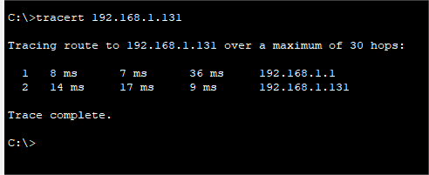

Figure 3: traceroute successful

DHCP Functionality Verification
The DHCP functionality test confirms that devices in each VLAN receive appropriate IP addresses automatically and that the DHCP server configuration aligns with the network’s VLAN structure.
- IP Address Assignment Test: Each VLAN is tested to ensure that devices receive IP addresses within the correct subnet. For example, devices in VLAN 10 (Admin/IT) should receive IP addresses from the 192.168.1.1 - 192.168.1.62 range, while devices in VLAN 20 (Finance/HR) should receive IP addresses from the 192.168.1.65 - 192.168.1.126 range.
- Default Gateway Configuration: Devices in each VLAN are checked to ensure they are assigned the correct default gateway for their subnet. For instance, devices in VLAN 10 should have the router’s sub-interface for VLAN 10 as their gateway (e.g., 192.168.1.1).
- DHCP Lease Verification: DHCP lease times and configurations are verified to ensure that IP addresses are leased and renewed correctly. Logs on the DHCP server are reviewed to confirm successful IP assignments and track any issues with address allocation.
- DHCP Relay Verification (if used): If DHCP relay is configured, it’s tested to verify that DHCP requests from devices in different VLANs reach the DHCP server and that responses are routed back correctly to the requesting VLAN.

These tests confirm that the network configuration meets operational standards and that all components function as intended. By thoroughly validating VLAN connectivity, inter-VLAN communication, DHCP functionality, and overall network performance, this testing process ensures a reliable and efficient network environment for the office.

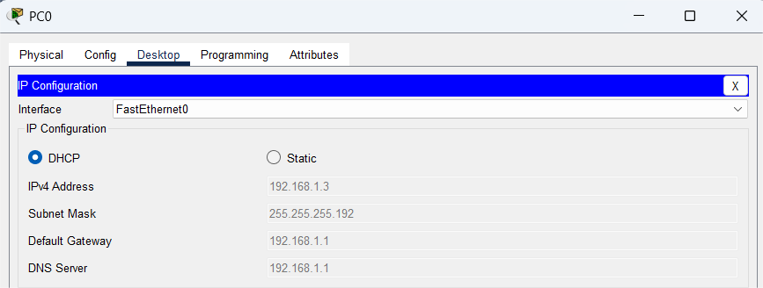

Figure 4:DHCP IP allocation

RESULTS AND EVALUATION

After implementing a small office network with VLAN segmentation, access control, and QoS configurations, results can be evaluated based on connectivity, security, and efficiency within each department. Ideally, the network should facilitate smooth communication across VLANs where necessary, while maintaining strict access control between departments, creating a secure and reliable working environment for employees.

Performance Metrics
Performance metrics, such as bandwidth utilization, latency, and packet loss, help gauge the effectiveness of the network configuration. In a well-configured office network, latency should be low, especially for high-priority traffic, and bandwidth should be evenly distributed among departments based on their needs. By monitoring these metrics, administrators can verify that the network is performing as expected, with minimal bottlenecks or disruptions, ensuring a productive workspace for each VLAN.

.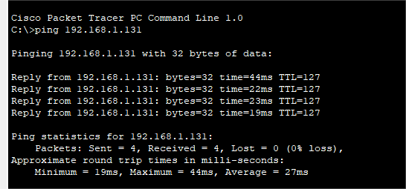

Figure 5: performance measure through ping time

CONCLUSION

The small office network design, with VLAN segmentation, Layer 3 switching, and access controls, effectively supports secure, efficient communication between departments. By implementing structured configurations and security measures, the network enables reliable connectivity while protecting sensitive data. This setup not only meets the immediate operational needs but also lays a scalable foundation for future growth.

Summary
This project involved designing and configuring a network for a small office environment, emphasizing VLANs, QoS, and monitoring. The network components, such as routers, switches, and access points, were configured to enhance performance, security, and manageability across departments. The use of testing and performance metrics verified that each VLAN operated smoothly and that resources were allocated effectively.

Lessons Learned
Throughout this project, we learned the importance of network segmentation, especially in ensuring data privacy and managing traffic efficiently. We also recognized the value of testing configurations in a simulation environment before implementation, as it minimizes deployment risks. Lastly, effective monitoring and performance metrics proved essential for maintaining a secure, high-performing network, highlighting key areas for proactive management and troubleshooting.

REFERENCES

- C. N. Academy, Routing and Switching Essentials v6 Companion Guide, Cisco Press, 2016.

- T. Lammle, CCNA Routing and Switching Study Guide: Exams 100-101, 200-101, and 200- 120, 7th ed., Sybex, 2016.
- R. Sweeney, Inter-VLAN Routing on Cisco Routers and Switches, Amazon Digital Services LLC, 2017.
- Cisco Systems, Configuring VLANs and Inter-VLAN Routing, Cisco Documentation, 2018. Available: https://www.cisco.com/c/en/us/support/docs/lan-switching/inter-vlan- routing/41860-howto-L3-intervlanrouting.html
- A. Vahid and S. Lysecky, Introduction to Networking: How the Internet Works, zyBooks, 2017.
- R. Teare, CCENT/CCNA ICND1 100-105 Official Cert Guide, 1st ed., Cisco Press, 2016.
- D. Bombal, Cisco Packet Tracer Labs for Beginners, YouTube Series, 2019. Available: https://www.youtube.com/user/davidbombal

Appendices

Abbreviations:

- ACL – Access Control List

- CS – Customer Service

- DHCP – Dynamic Host Configuration Protocol

- IP – Internet Protocol

- LAN – Local Area Network

- NAT – Network Address Translation

- PAT – Port Address Translation

- PC – Personal Computer

- QoS – Quality of Service

- SNMP – Simple Network Management Protocol

- SVI – Switch Virtual Interface

- VLAN – Virtual Local Area Network

- VoIP – Voice over Internet Protocol

- WAN – Wide Area Network

These abbreviations are integral to understanding the components and configuration used in the small office network project.

